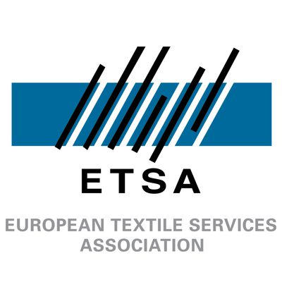

ETSA Awards Application Form

Amsterdam 2026



Climate Impact Award
Please note that the applications will be assess based on the following criteria:

- Measurable environmental impact (e.g. emissions, recycling, resource efficiency)
- Innovation in sustainability practices (scalable or disruptive approaches)
- Evidence-based results with transparent “before vs after” data
- Alignment with broader frameworks (EU Green Deal, net-zero, circular economy)
- Long-term vision and industry influence, including communication via digital channels

The deadline for applications is set on May 24th. To apply, please send the completed application form to our Policy and Communications Coordinator at julien.bourgeois@etsa-europe.org

Name:

Company or National Association represented:

Position in the company or National Association:

Name of the project that fulfils the award criteria:

Part A (max 500 words)

Please describe this initiative:

Part B (max 200 words per response)

What was the total cost of the project? (specify currency)

Did you receive any external financial assistance on this initiative? (e.g. EU funding, national aid, donors, sponsorship)

How many people were involved in this project?

How was this project promoted and disseminated?

Additional links providing information on the project:

