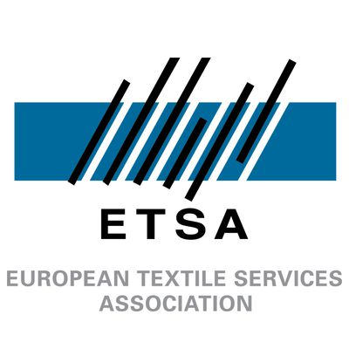

ETSA Awards Application Form

Amsterdam 2026



National Association of the Year
Please note that the applications will be assess based on the following criteria:

- Effectiveness of lobbying and legislative achievements
- Innovation in industry development initiatives
- Influence on policy and regulatory environment
- Measurable impact on the national industry
- Strategic execution, partnerships, and long-term sustainability of impact

The deadline for applications is set on May 24th. To apply, please send the completed application form to our Policy and Communications Coordinator at julien.bourgeois@etsa-europe.org

Name:

Company or National Association represented:

Position in the company or National Association:

Name of the project that fulfils the award criteria:

Part A (max 500 words)

Please describe this initiative:

Part B (max 200 words per response)

What was the total cost of the project? (specify currency)

Did you receive any external financial assistance on this initiative? (e.g. EU funding, national aid, donors, sponsorship)

How many people were involved in this project?

How was this project promoted and disseminated?

Additional links providing information on the project:

